1. Introduction
Data visualization is an important part of data science because it helps convert large and complex datasets into meaningful visual information. In this task, advanced data visualization techniques are used to analyze the Online Retail dataset and communicate important patterns, trends, and relationships in a simple way.
The main objective of this task is to explore business-related data using Python visualization libraries and develop a clear data-driven story for both technical and non-technical audiences. The analysis focuses on revenue trends, country-wise performance, product-wise revenue, transaction revenue distribution, and the relationship between quantity and revenue.
Five different visualizations were created using Matplotlib. Each visualization was selected according to the type of information it needs to communicate. The charts help identify important trends, high-performing countries and products, unusual transaction values, and relationships between variables.
The analysis provides useful business insights that can support better understanding of sales performance and help identify areas that may require further investigation.

2. Dataset Description
The dataset used for this task is the Online Retail dataset, which contains transactional information from an online retail store. It includes information about invoices, products, quantities, prices, customers, dates, and countries.
The original dataset contains 541,909 records and 8 columns. The main columns are:
- InvoiceNo – Invoice or transaction number
- StockCode – Product identification code
- Description – Product or transaction description
- Quantity – Number of items purchased
- InvoiceDate – Date and time of the transaction
- UnitPrice – Price per item
- CustomerID – Customer identification number
- Country – Country of the customer
For this visualization task, the data was cleaned by removing duplicate records, removing rows with missing product descriptions, and keeping only transactions with positive quantity and positive unit price. A new Revenue column was created using:
Revenue = Quantity × UnitPrice
A Month column was also created from the invoice date to analyze monthly revenue trends.
After preprocessing, 524,878 records and 10 columns were used for the visualization analysis.
Dataset source: UCI Online Retail Dataset.

3. Methodology
The visualization process was carried out using Python and the Pandas and Matplotlib libraries. The analysis followed a systematic process to prepare the data and create meaningful visualizations.
Step 1: Data Loading
The Online Retail dataset was loaded into a Pandas DataFrame using the read_excel() function.
Step 2: Data Cleaning
Duplicate records were removed from the dataset. Rows with missing product descriptions were also removed because product descriptions were required for product-level analysis.
Step 3: Valid Transaction Filtering
Only transactions with a quantity greater than zero and a unit price greater than zero were retained. This helped focus the analysis on valid sales transactions.
Step 4: Feature Creation
A new Revenue column was created by multiplying Quantity by UnitPrice. A Month column was also created from InvoiceDate to support monthly revenue analysis.
Step 5: Visualization
Five visualizations were created to communicate different aspects of the data:
- Monthly Revenue Trend — to identify changes in revenue over time.
- Top 10 Countries by Revenue — to compare geographical revenue performance.
- Top 10 Products by Revenue — to identify high-revenue transaction descriptions.
- Distribution of Transaction Revenue — to understand the spread of transaction-level revenue.
- Quantity vs Revenue — to examine the relationship between quantity sold and transaction revenue.
Step 6: Storytelling and Interpretation
Each visualization was interpreted based on the patterns, trends, and unusual observations visible in the chart. The findings were then connected to possible business implications so that the results could be understood by a non-technical audience.

4. Visualization 1 — Monthly Revenue Trend
Purpose:
The monthly revenue trend visualization was created to understand how the company's revenue changed over time. A line chart was selected because it clearly shows changes and trends across consecutive months.
Visualization:
monthly_revenue_trend.png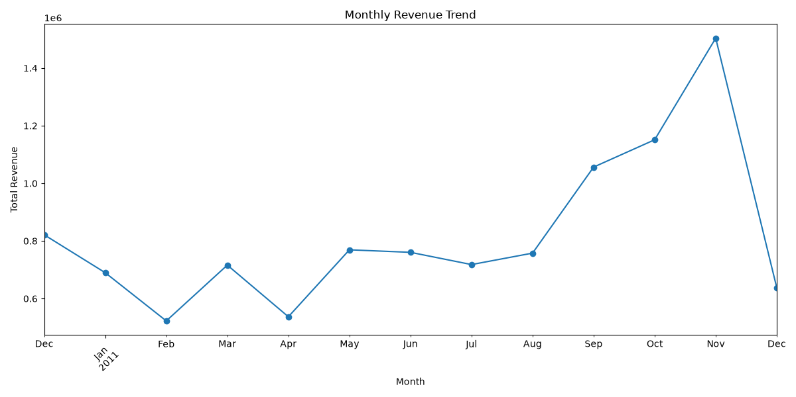

Interpretation:
The line chart shows variations in total revenue across different months. Revenue changes from month to month, indicating that sales activity was not constant throughout the period. The chart makes it easy to identify periods of increasing and decreasing revenue and observe the overall sales pattern over time.
The analysis shows that November 2011 had the highest total revenue among the months in the cleaned dataset.
Business Implication:
The monthly trend

5. Visualization 2 — Top 10 Countries by Revenue
Purpose:
This visualization was created to compare revenue generated by different countries. A horizontal bar chart was selected because it makes it easy to compare multiple countries and clearly identify the highest and lowest revenue values within the top 10.
Visualization:

top_10_countries_revenue.png
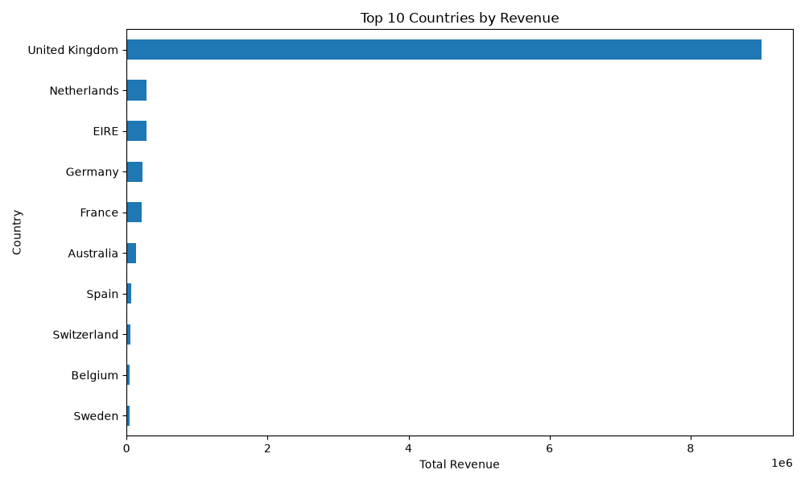
Interpretation:
The chart shows the top 10 countries based on total revenue. The United Kingdom generated the highest revenue among all countries in the cleaned dataset. The other countries in the top 10 generated considerably lower revenue compared with the United Kingdom.
This indicates that the business had a strong concentration of revenue in the United Kingdom, while other international markets contributed smaller portions of the total revenue.
Business Implication:
The business can use this information to understand its strongest geographical markets. The United Kingdom can be studied further to identify the factors contributing to its strong performance. At the same time, the other markets could provide opportunities for targeted marketing, customer acquisition, and expansion strategies.
Why This Visualization Was Chosen:
A horizontal bar chart provides a direct comparison between categories. It is particularly useful when category names are relatively long because the labels remain easier to read than in a vertical bar chart.

6. Visualization 3 — Top 10 Products by Revenue
Purpose:
This visualization was created to identify the transaction descriptions that generated the highest total revenue. A horizontal bar chart was used because it provides a clear comparison between the top revenue-generating descriptions.
Visualization:

top_10_products_revenue.png
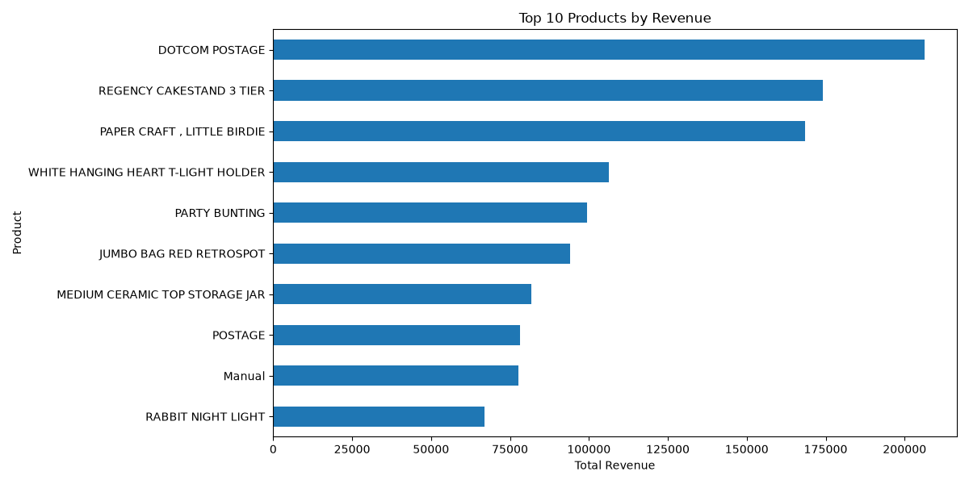
Interpretation:
The chart presents the top 10 transaction descriptions based on total revenue. DOTCOM POSTAGE appears as the highest-revenue description in the analysis.
It is important to note that DOTCOM POSTAGE represents a postage-related transaction description rather than a typical physical product. Therefore, this result should be interpreted as the highest-revenue transaction description rather than simply the best-selling physical product.
The remaining descriptions also contribute significant amounts of revenue, showing that revenue is distributed across several high-performing items.
Business Implication:
This analysis can help a business identify transaction categories that contribute strongly to revenue. High-revenue descriptions can be investigated further to understand their sales volume, pricing, and customer demand. The business can also use these findings when planning product management and sales strategies.
Why This Visualization Was Chosen:
A horizontal bar chart allows multiple categories to be compared quickly and makes long product or transaction descriptions easier to read. Sorting the values also makes the highest-revenue descriptions immediately visible.

7. Visualization 4 — Distribution of Transaction Revenue
Purpose:
This visualization was created to understand how transaction revenue is distributed across the cleaned dataset. A histogram was selected because it shows how frequently different revenue ranges occur.
Visualization:

revenue_distribution.png
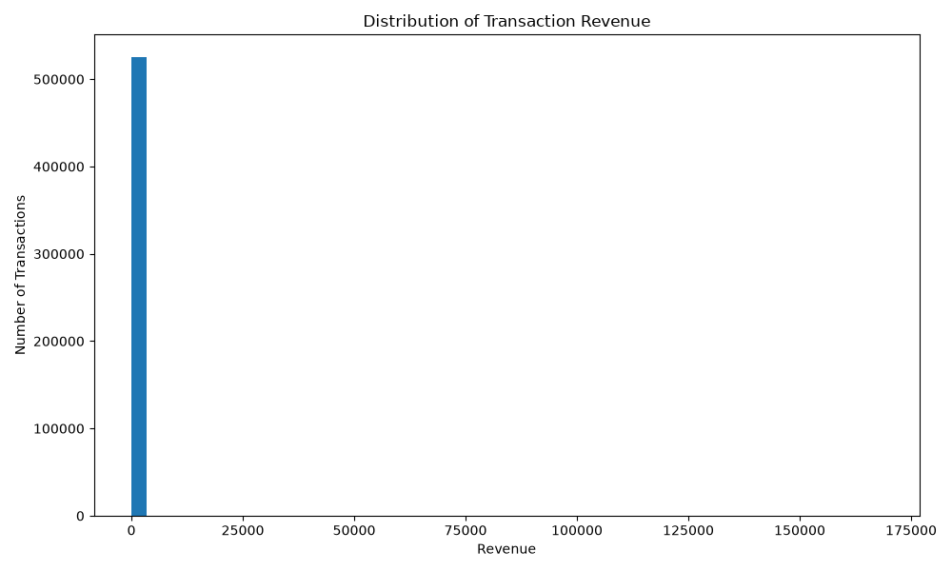
Interpretation:
The histogram shows that most transactions have relatively low revenue values, while a smaller number of transactions have much higher revenue. This creates a distribution with a long right tail.
The analysis shows that the average transaction revenue was approximately 20.28, indicating that most individual transactions were relatively small compared with a limited number of high-value transactions.
Business Implication:
The business can use this information to distinguish between typical transactions and unusually high-value transactions. High-value transactions could be investigated to understand whether they are associated with bulk purchases, specific customers, or particular transaction types.
Why This Visualization Was Chosen:
A histogram is useful for understanding the distribution of a numerical variable. It shows where observations are concentrated and makes unusually high or low values easier to identify.

8. Visualization 5 — Quantity vs Revenue
Purpose:
This visualization was created to examine the relationship between the quantity purchased and the revenue generated from each transaction. A scatter plot was selected because it allows the relationship between two numerical variables to be observed.
Visualization:

quantity_vs_revenue.png
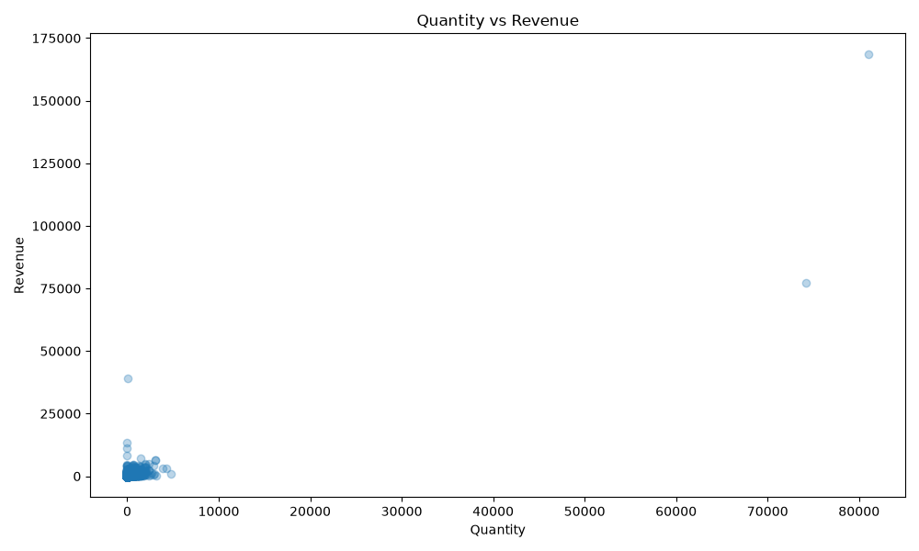
Interpretation:
The scatter plot shows the relationship between transaction quantity and revenue. Most transactions are concentrated around lower quantity and revenue values, while a smaller number of transactions have much higher values.
The plot also shows that higher quantities can be associated with higher transaction revenue. However, the relationship is not perfectly linear because revenue also depends on the unit price of the items purchased.
Business Implication:
Understanding the relationship between quantity and revenue can help the business identify high-volume transactions and investigate the factors that contribute to higher revenue. This information can support decisions related to pricing, product sales, and inventory planning.
Why This Visualization Was Chosen:
A scatter plot is effective for examining relationships between two numerical variables. It makes clusters, patterns, and unusual observations easier to identify than a simple table of values.

9. Key Insights
The visualization analysis provided the following important insights:
- The total revenue generated from the cleaned dataset was approximately 10,642,110.80.
- The average revenue per transaction was approximately 20.28.
- The United Kingdom was the highest-revenue country.
- November 2011 was the highest-revenue month.
- DOTCOM POSTAGE appeared as the highest-revenue transaction description.
- The average quantity per transaction was approximately 10.62.
- Most transactions had relatively low revenue, while a smaller number of transactions had much higher revenue values.
- The quantity-versus-revenue visualization showed that higher quantities can contribute to higher transaction revenue, although unit price also affects the final revenue.
Overall, the visualizations helped convert the transaction data into an understandable story about revenue trends, geographical performance, transaction descriptions, revenue distribution, and purchasing quantity.

10. Business Implications
The findings from the visualizations can provide useful information for business decision-making. The strong revenue contribution from the United Kingdom suggests that this market is important and should continue to be monitored and supported.
The monthly revenue trend can help the business identify high-performing periods and improve planning for inventory, marketing, and sales activities. The country-level analysis can also help identify markets that may have potential for future growth.
The transaction-description analysis can help the business investigate which descriptions contribute significantly to revenue. However, descriptions such as DOTCOM POSTAGE should be interpreted carefully because they may represent service or transaction-related charges rather than physical products.
The revenue distribution highlights the presence of a relatively small number of high-value transactions. These transactions can be studied further to understand the factors contributing to higher revenue.
Finally, the quantity-versus-revenue analysis can support decisions related to pricing, product demand, and inventory management.

11. Conclusion
This task demonstrated how data visualization can be used to analyze and communicate information from a large retail dataset. After cleaning and preparing the Online Retail dataset, five different visualizations were created to study revenue trends, geographical performance, transaction descriptions, revenue distribution, and the relationship between quantity and revenue.
The visual analysis showed that the United Kingdom was the highest-revenue country, November 2011 was the highest-revenue month, and DOTCOM POSTAGE was the highest-revenue transaction description. The visualizations also showed that most transactions had relatively low revenue, while a smaller number of transactions had much higher values.
Overall, the analysis demonstrates how appropriate chart selection and clear interpretation can transform raw data into useful insights. These insights can support business decision-making and provide a foundation for further analysis.

